Charley Kirk
Dr. Rhodes
Data Mining
27 September 2024
Classification Homework
To save space I will show the parameters for the first colic.arff tree and then for each successive tree I will list the parameters that have changed from the previous tree. The class variable for each of the colic.arff trees is outcome.

Tree 1 for colic.arff:
batchSize 100
binarySplits False
collapseTree True
confidenceFactor 0.25
debug False
doNotCheckCapabilities False
doNotMakeSplitPointActualValue False
minNumObj 2
numDecimalPlaces 2
numFolds 3
reducedErrorPruning False
saveInstanceData False
seed 1
subtreeRaising True
unpruned False
useLaplace False
useMDLcorrection True

About 66.94% of instances were correctly classified.

Tree 2 for colic.arff:
BinarySplits: True

About 65.57% of instances were correctly classified.

Tree 3 for colic.arff:
binarySplits False
minNumObj 4
unpruned True

About 69.13% of instances were correctly classified.

Tree 4 for colic.arff:
minNumObj 2
subtreeRaising False
unpruned False

About 67.76% of instances were correctly classified.

Tree 5 for colic.arff:
minNumObj 3

About 68.31% of instances were correctly classified.

Of these 5 colic trees the one that gave me the best result was Tree 3. I’ll give the parameters below:
batchSize 100
binarySplits False
collapseTree True
confidenceFactor 0.25
debug False
doNotCheckCapabilities False
doNotMakeSplitPointActualValue False
minNumObj 4
numDecimalPlaces 2
numFolds 3
reducedErrorPruning False
saveInstanceData False
seed 1
subtreeRaising True
unpruned True
useLaplace False
useMDLcorrection True

I noticed that increasing the value of minNumObj could sometimes improve the accuracy, but past a certain level increasing the value could also make the accuracy worse. The value 4 may not always be the sweet spot but it seemed like it might have been for this general set of parameter values. I did also try changing the value of unpruned a few times to see the effect. I think that pruning can have an effect on overfitting so it could be that not pruning is better in some sitautions?

Like for colic.arff I will show the parameters for the first lymph.arff tree and then for each successive tree I will list the parameters that have changed from the previous tree. The class variable for each of the lymph.arff trees is class.

Tree 1 for lymph.arff:
batchSize 100
binarySplits False
collapseTree True
confidenceFactor 0.25
debug False
doNotCheckCapabilities False
doNotMakeSplitPointActualValue False
minNumObj 5
numDecimalPlaces 2
numFolds 3
reducedErrorPruning False
saveInstanceData False
seed 1
subtreeRaising False
unpruned False
useLaplace False
useMDLcorrection True

Exactly 75% of instances were correctly classified.

Tree 2 for lymph.arff:
binarySplits True
collapseTree False
confidenceFactor 0.4

About 79.05% of instances were correctly classified.

Tree 3 for lymph.arff:
binarySplits False

About 78.38% of instances were correctly classified.

Tree 4 for lymph.arff:
reducedErrorPruning True

Exactly 75% of instances were correctly classified.

Tree 5 for lymph.arff:
binarySplits True
collapseTree True
confidenceFactor 0.25
reducedErrorPruningFalse

About 77.70% of instances were correctly classified.

Of these 5 lymph trees the one that gave me the best result was Tree 2. I’ll give the parameters below:
batchSize 100
binarySplits True
collapseTree False
confidenceFactor 0.4
debug False
doNotCheckCapabilities False
doNotMakeSplitPointActualValue False
minNumObj 5
numDecimalPlaces 2
numFolds 3
reducedErrorPruning False
saveInstanceData False
seed 1
subtreeRaising False
unpruned False
useLaplace False
useMDLcorrection True
I guess it’s a little hard to say why this choice of parameter values worked out better than the others. I tried to experiment with some different parameters than I did for the colic trees. On the whole it seems like having binarySplits set to True worked out better for the lymph trees than for the colic trees. I believe raising the confidenceFactor from 0.25 to 0.4 means that more pruning was performed so maybe in this case more pruning was actually better.

Below are the graphical representations for each of my trees:

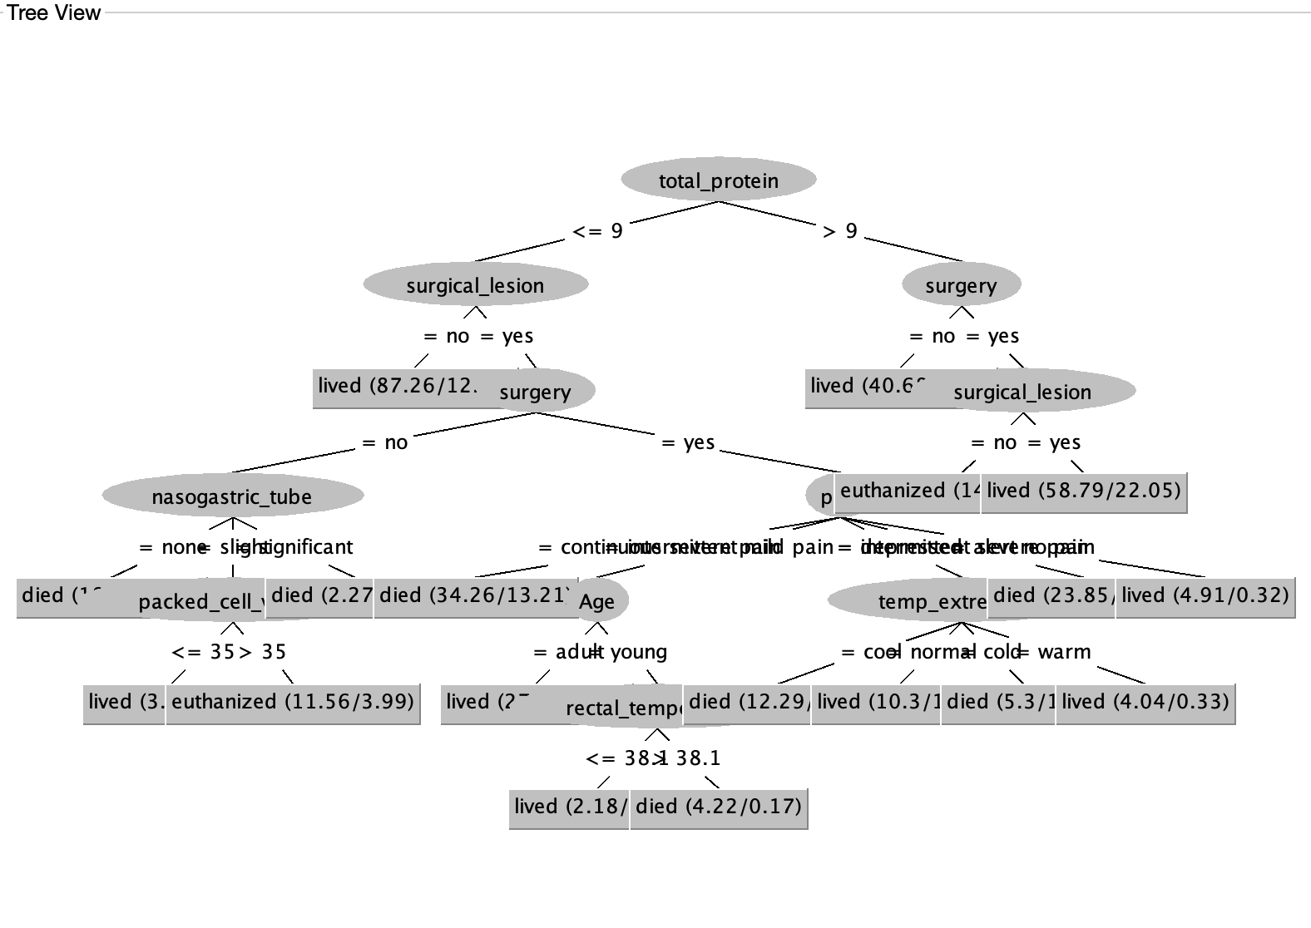
Colic Tree 1:

Colic Tree 2:

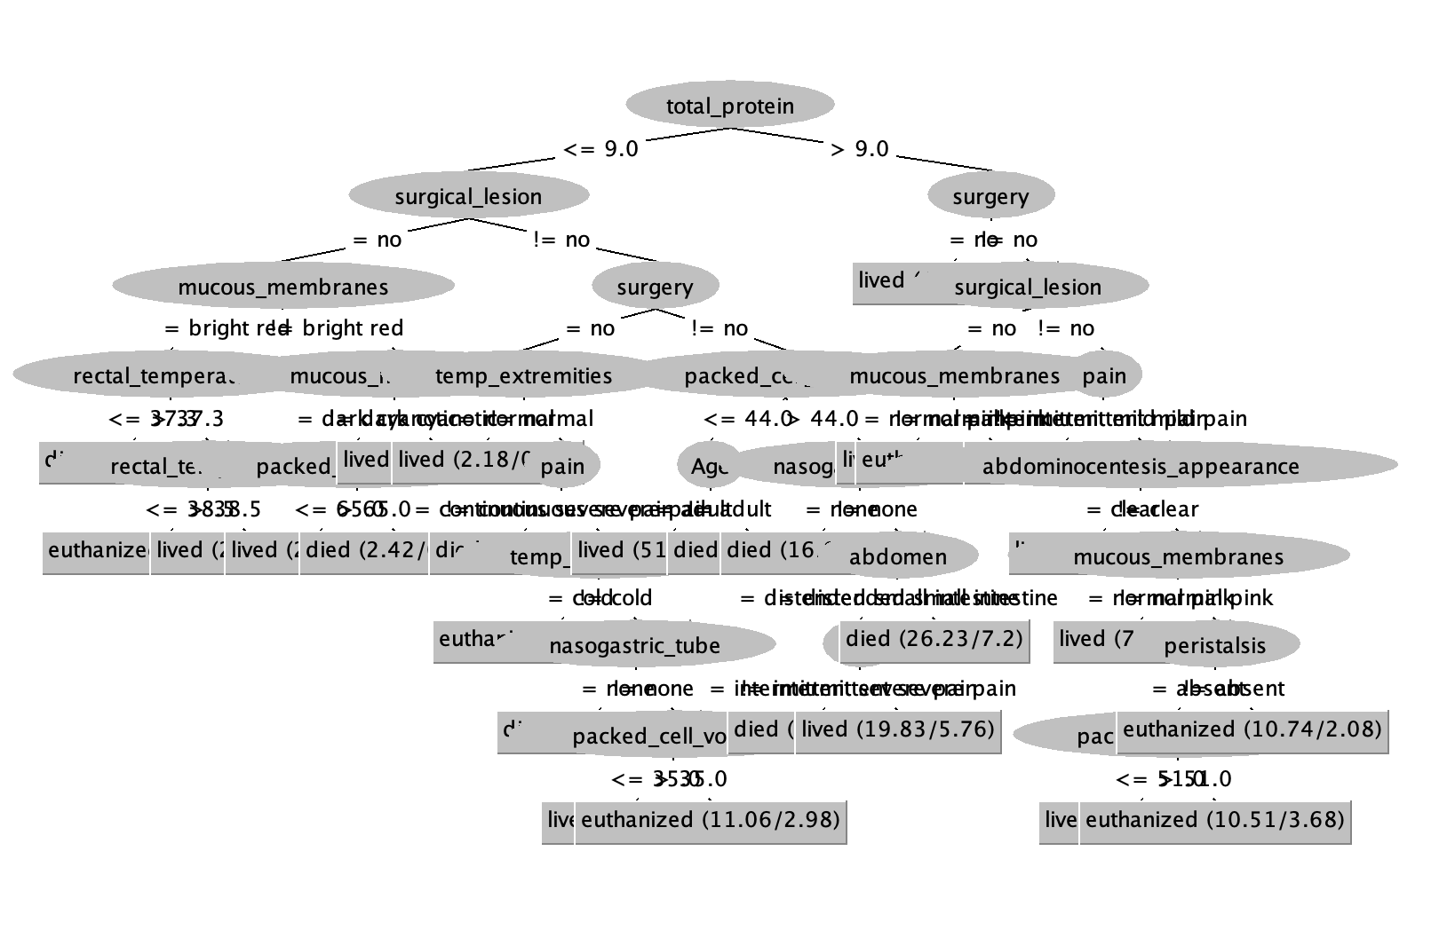

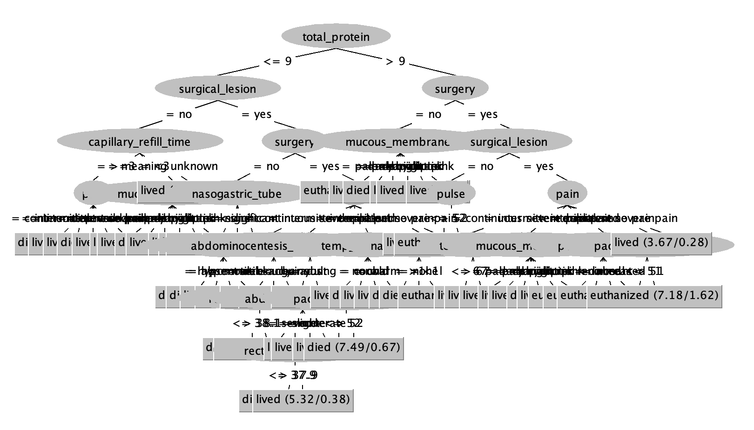
Colic Tree 3:

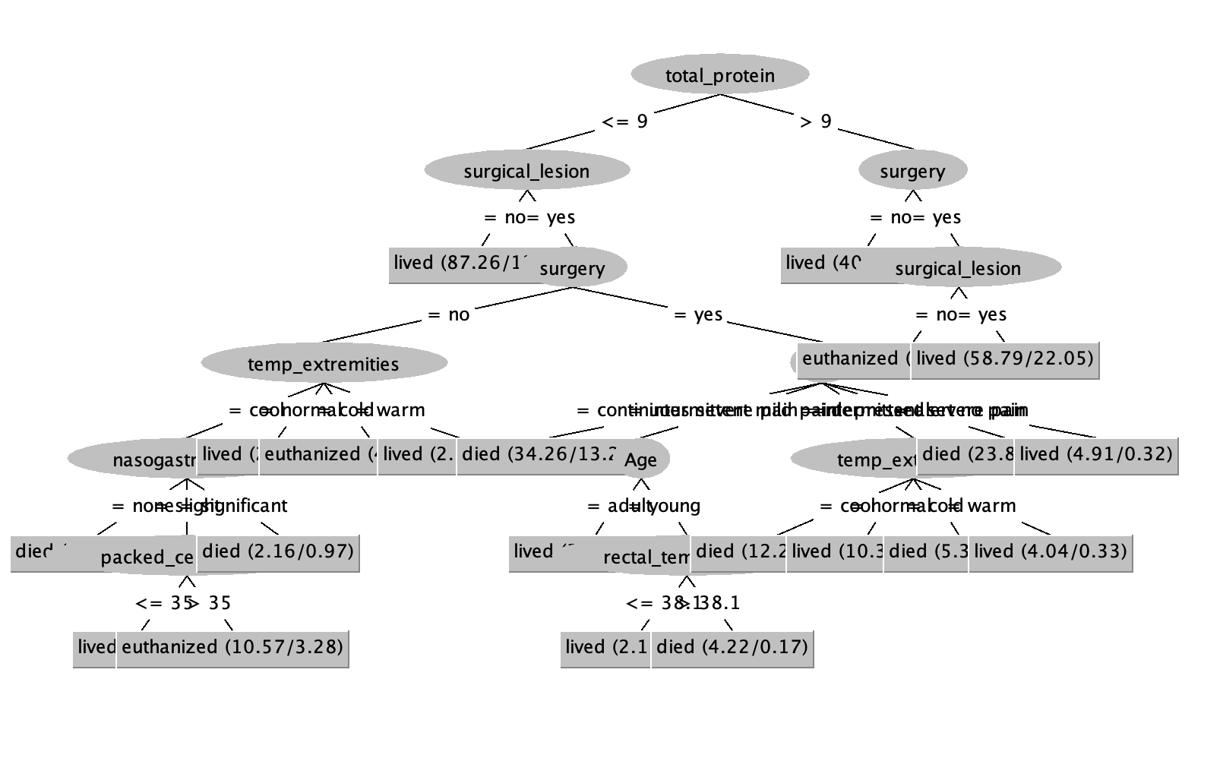
Colic Tree 4:

Colic Tree 5:

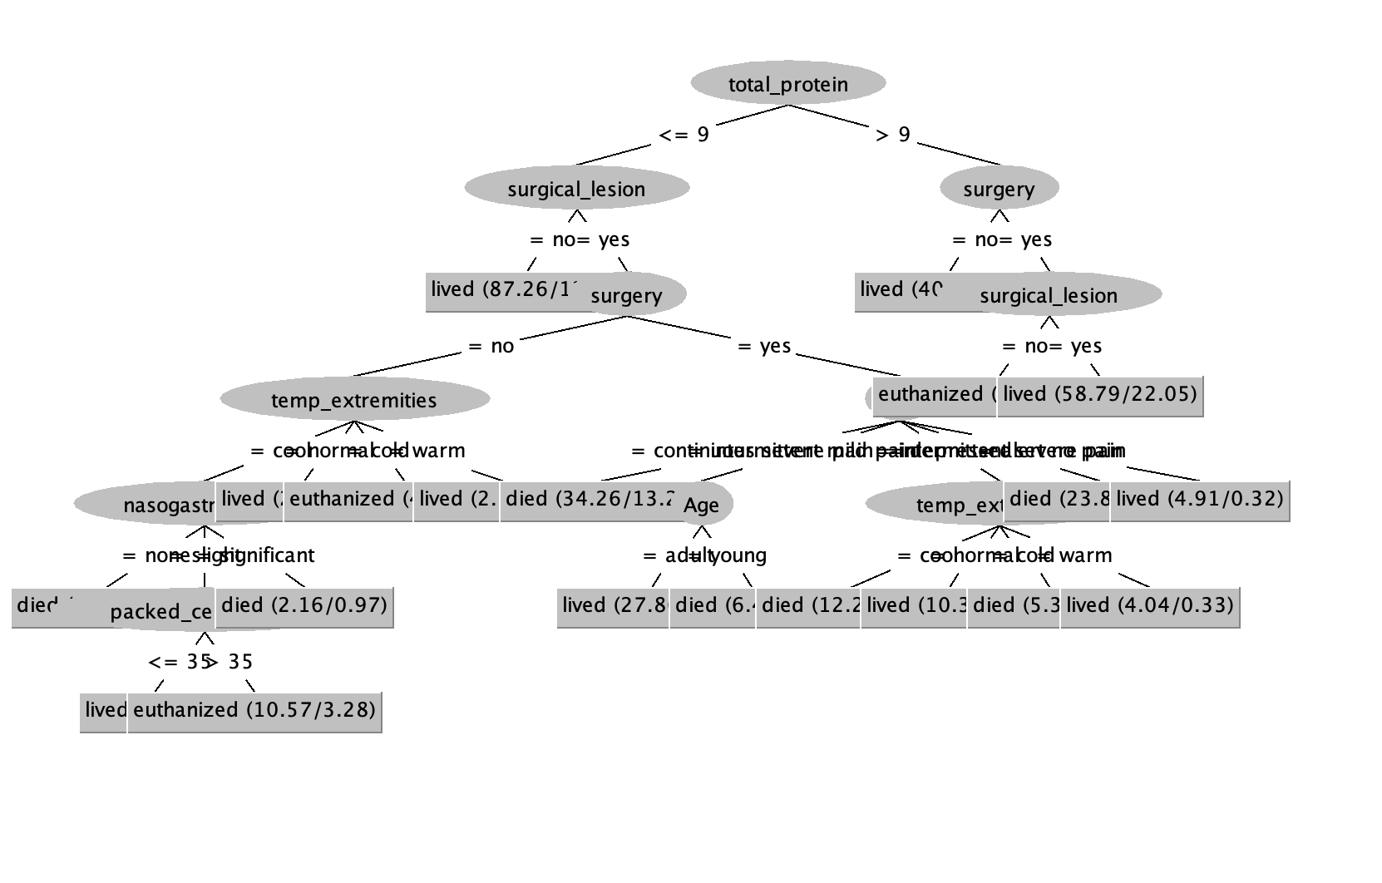

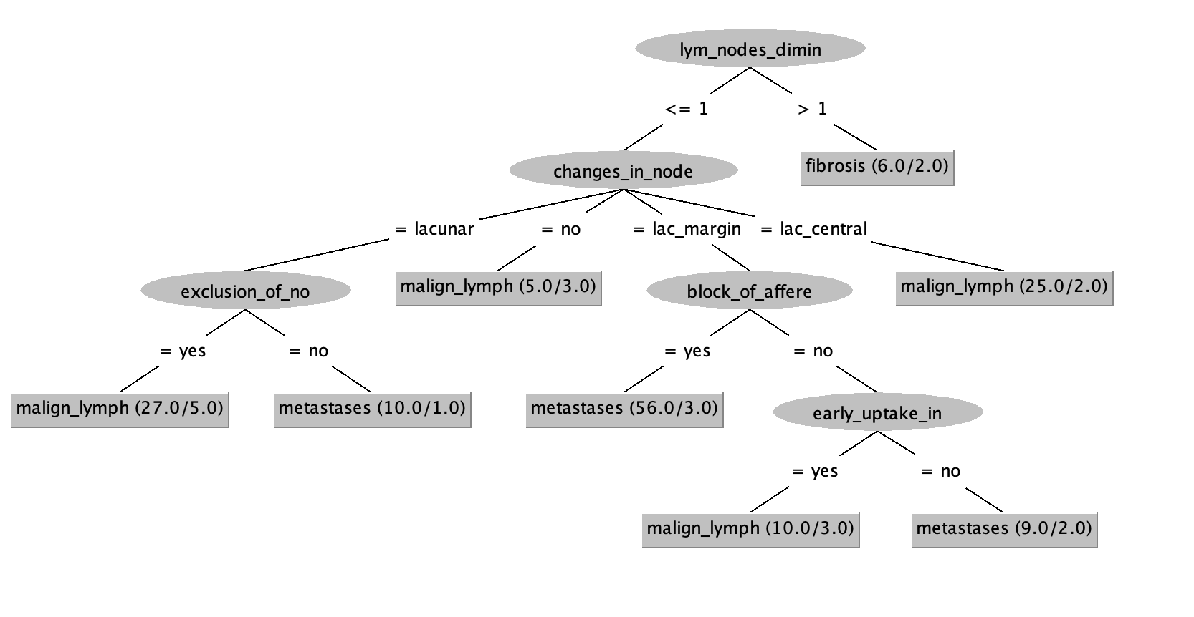
Lymph Tree 1:

Lymph Tree 2:

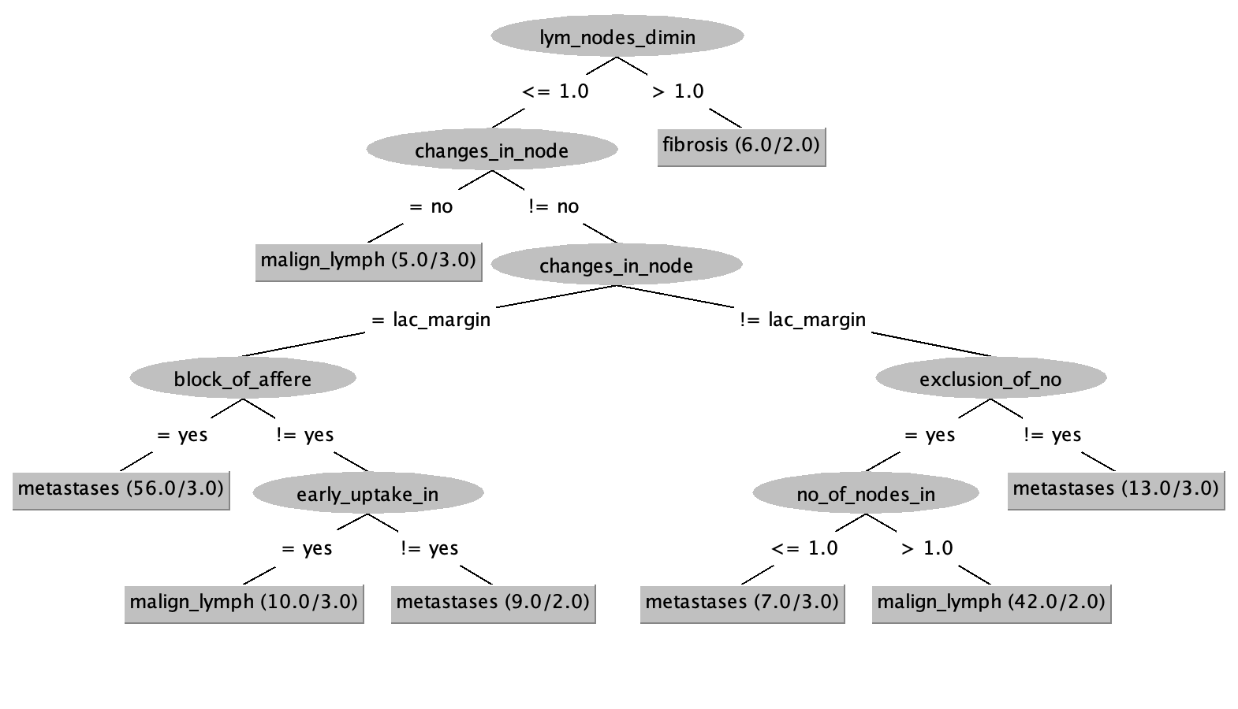

Lymph Tree 3:

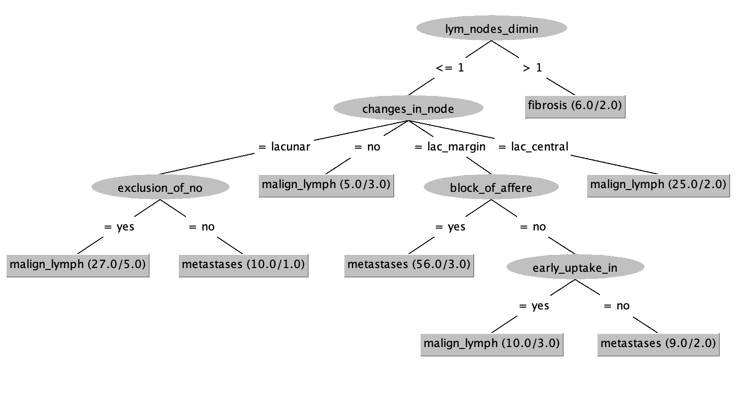

Lymph Tree 4:
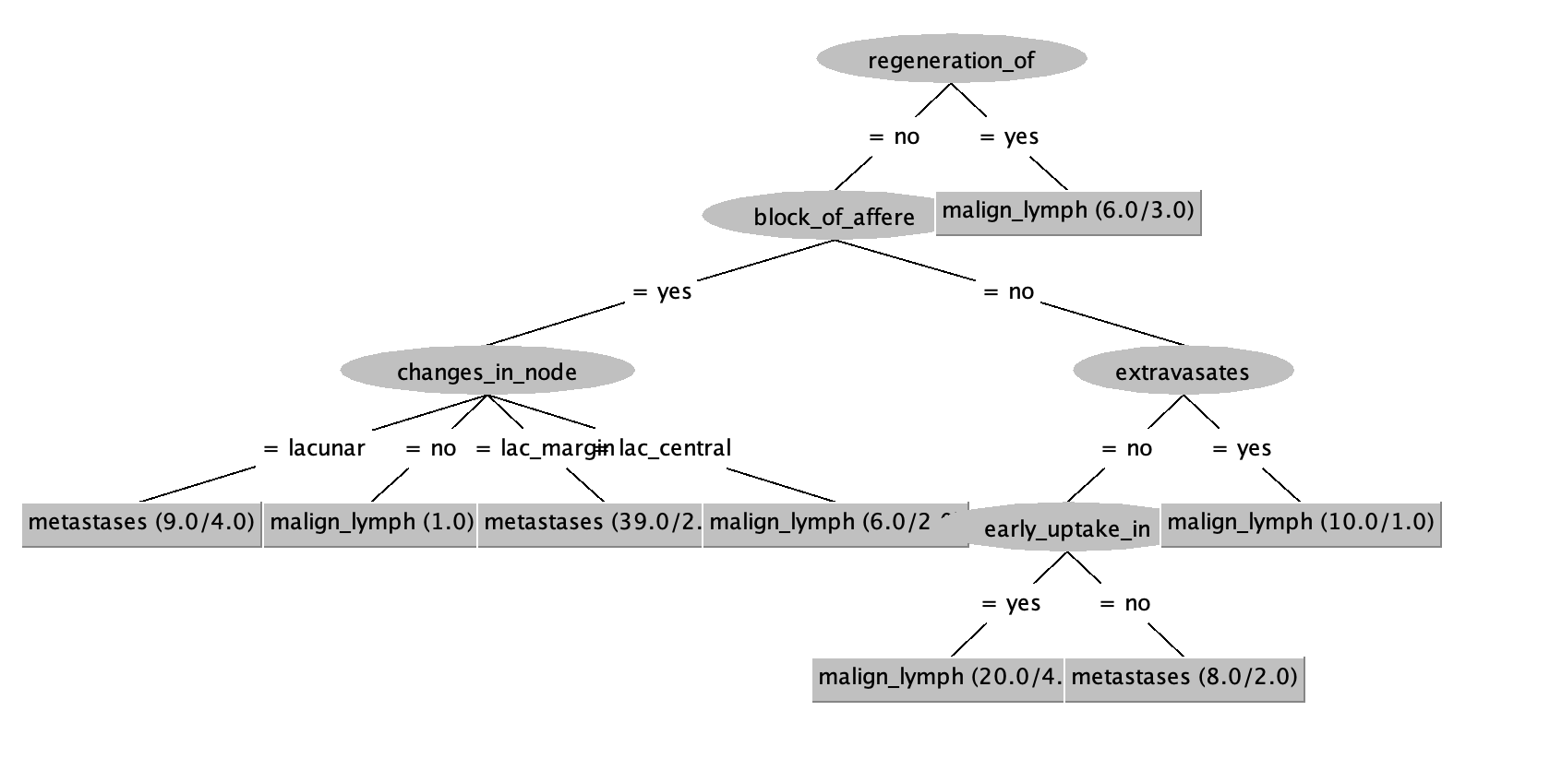

Lymph Tree 5:
